**Most loved UI Interface:** Apple Website (apple.ca or apple.com depends on region)

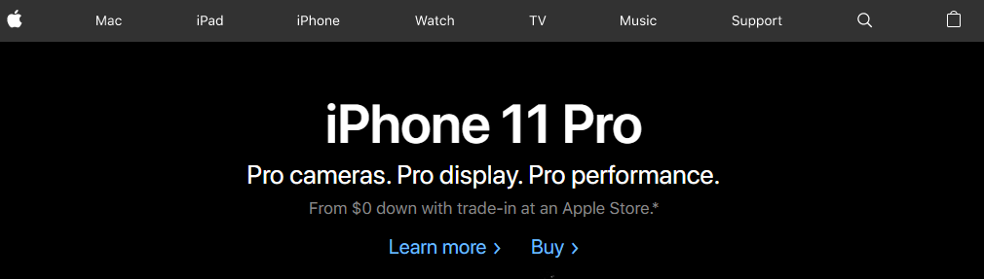

In general, Apple has given its users a really nice, simple and organized interface in my opinions. Right on the top of the website, Apple classified its product type into section and there will be a sub-section under it. This is really a helpful thing especially for people who is not so familiar with technology or senior since they don’t have to fuzz around as there is no animate option (like it will display a list of the product if you move the cursor to the button)

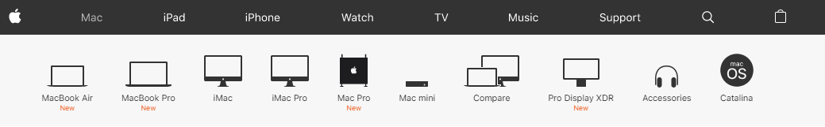

For example, a user who is looking to discover what is the new Mac products are being released this year, they can just simply go to the Mac section, and a list of Mac products will be displayed, with the word “New” indicated for this year released product. However, I do have to admit that I found myself a bit inconvenience with the Mac sub-section. They could group the Macbook Air and Macbook Pro together under another section called Macbook, and the same thing for iMac and Mac to organized it a bit better.

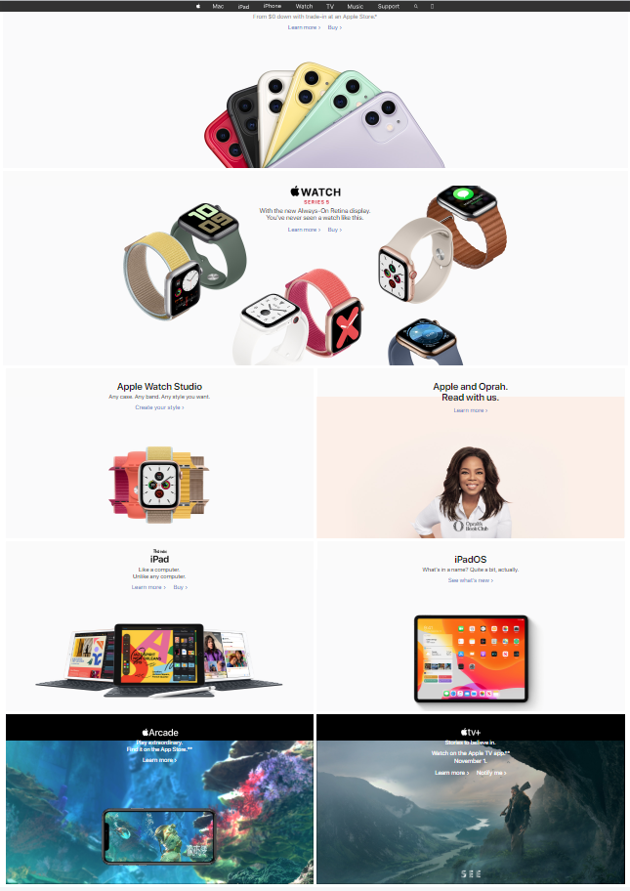

Another layout that I loved from Apple is their ability to organize things to give their users the best UI possible. On the home page, they always introduce to users what they have released on their most recent Apple Release event. They create a very catchy attention layout by giving each of the introducing section an image to represent it and the details will only be shown if the user is clicked on it. Using an image instead of catchy words seems to have better effects in memory since users can easily be attracted to a good and beautiful image than catchy words.

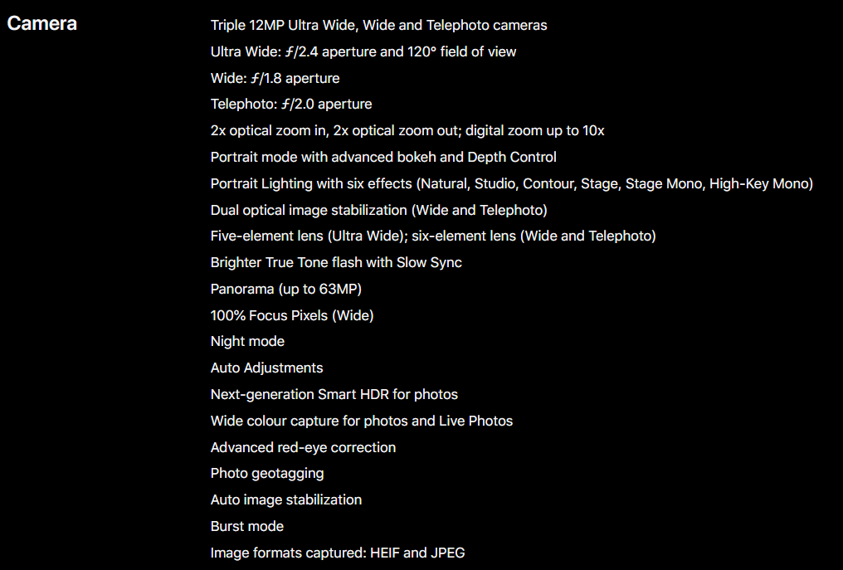

The website is designed to fits with the knowledge of each user. That being said, if a user is a non-technical people, non-technical information will be provided (like Ultrawide, Wide and Telephoto Camera). On the other side, if the user is a well-known technical person, more information will be given such as Ultrawide f/2.4 with a 120-degree angle of view, Wide f/1.8 and Tele f/2.0 with 2 optical zooms in/out and 10x digital zoom.

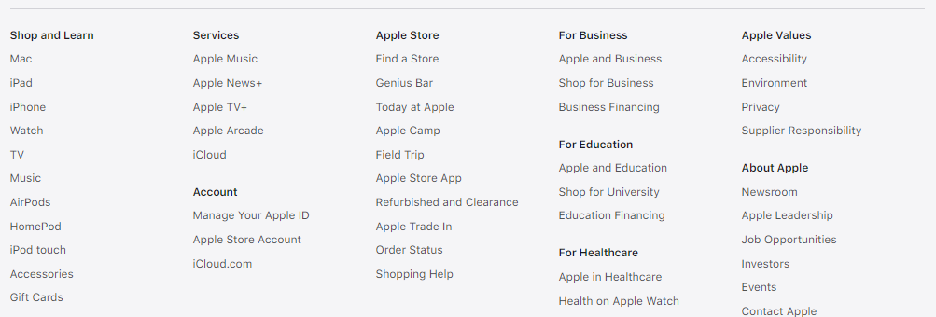

This section is located at the end of the page and not many users are aware of this. It gives the user a bit more in-depth of what Apple provides to users besides selling the products. This section contains many new features users could try on or find an answer/solution here.

Overall, Apple is doing a really good job of designing its website as it absolutely works on any age range, genders, no matter their education level and especially any region, culture or ethnic (Apple website can be translated on to another language if the designated country doesn’t have English as their official language). The website was built on a level where users can come and discover new products, or explore in-depth about a product and even purchase it. So far, whenever I have a question about an Apple product, most of the information is already on the website and I rarely have to chat, call or walk-in to find the answer.

**Most hated UI Interface:** Seneca Mobile App

There have been a lot of complaints about the Seneca Mobile App about how inconvenience it is (although there is some convenience part). First of all, is the layout. The layout is pretty simple, with some main functions implemented for the user such as Student’s time table, Seneca Student Federation events, Paying school fee,... those basic ones.

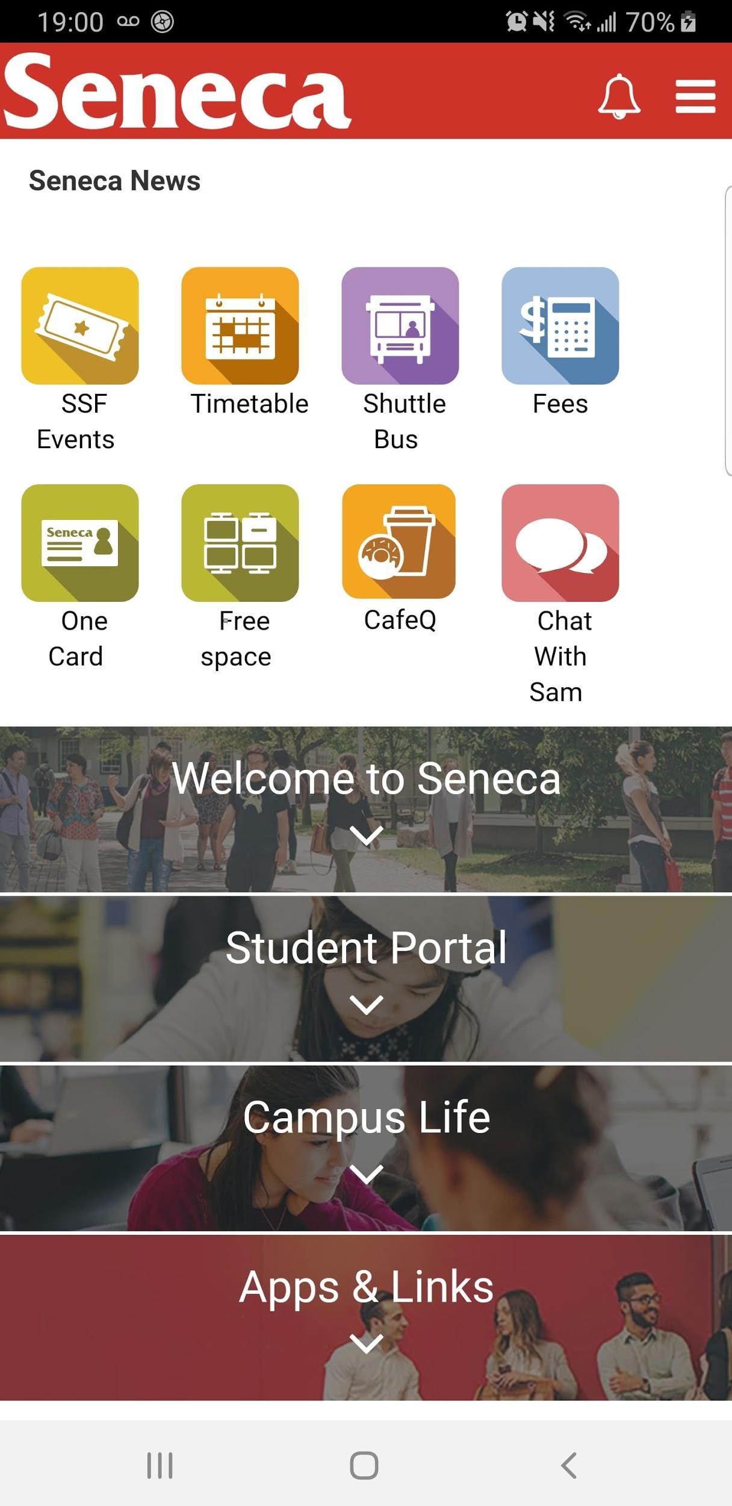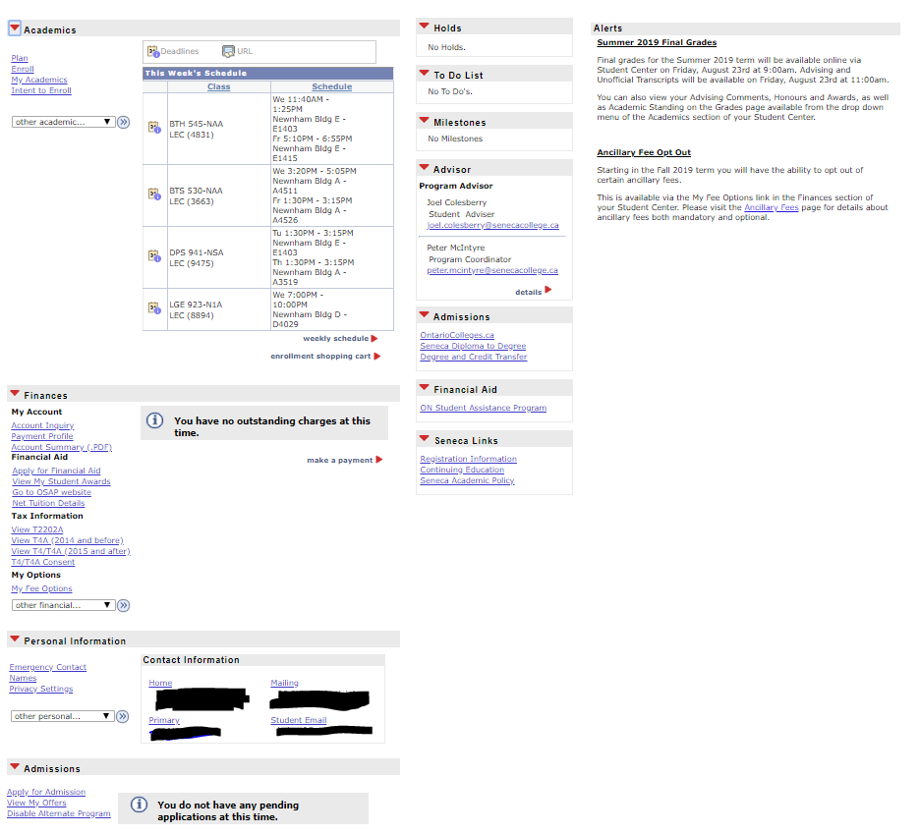

The app supposes to be designed as a smaller portable version of the Student Center, however, when we compare the Student Center website on a browser with this app, we can all tell how limited this app is. So far, all the functions I could use on the app (and it works pretty well) is the time table, shuttle bus schedule, paying tuition fees, check my OneCard balance and events. For the rest of the app, it will bring you to an external website where do you can do the functionality. Despite the app is really giving the users a working functionality, the pop-up website is still annoying to some people, at least to me. (P/S: Seneca App and Seneca Website was built by its student so it is understandable why the app is a bit crappy).

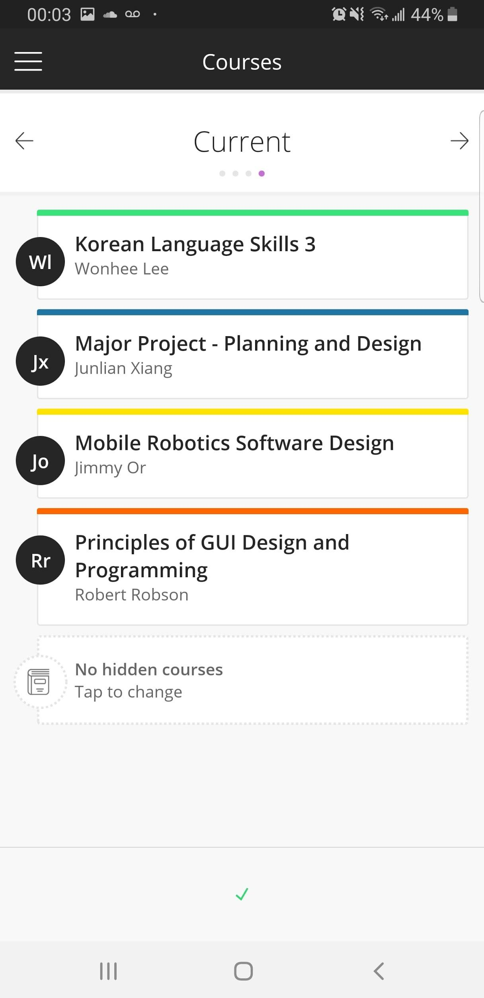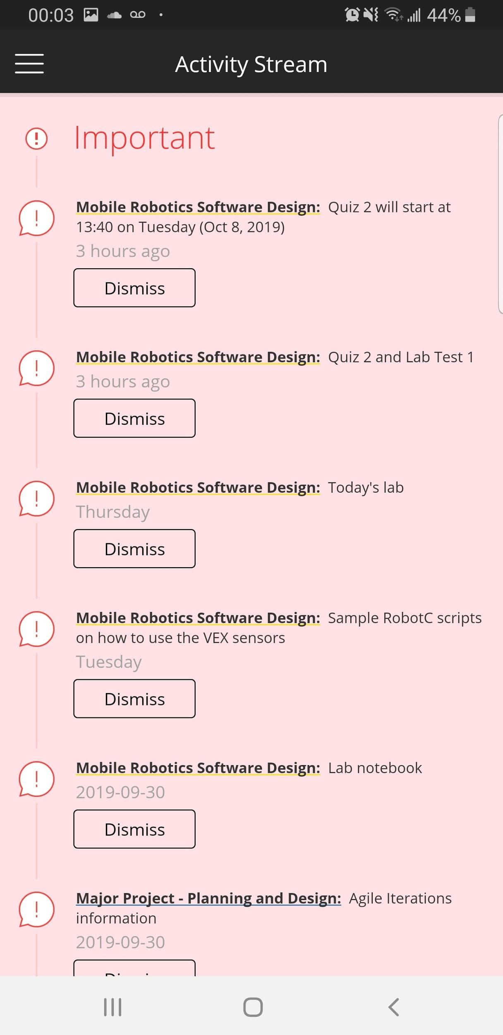

The UI design is a bit in an old-fashion style and it seems not to really fit with the modern society, where apps are constantly changing to give the user a better-looking design. Oneplus thing is they also just implement the functions if they can let the user do it directly in the app. Compare with Blackboard App, this is known as a 3rd party app developed with an API for each school and stored the information for each course and give a notification whenever there is an update. This modern developed app gives the user a better looking as well as a smoother experience.

For the app in general, it is pretty easy to use for some basic function but when it comes to, let’s say “Free Space”, the user will be transferred into an Internet Browser where they can do the stuff and after that, they usually don’t know how to come back to the app so these must be used for people with a bit of technical knowledge. So far, the app only comes in English but it would be nice if they have English and French as French is Canadian 2nd language, and others if they want to attract more students from that country. For the app, it is designed for Seneca Student and Employee but I don’t personally think any Employee would use since they don’t really have an attractive design or give any attention at all. It seems that the app is lack of user using it as well as lack of feedback because this app looks exactly the same 4 years ago with no improvement at all and as we all know technology is a must up-to-date thing. The app perception is pretty good as the functionality was grouped into section related and users sometimes recognizes that there are more things they can use from the app. It seems that the app was designed in a really poor way that I’ve asked a few of my friends and they all admit that they delete the app just after a few tries. They would rather go to the real Student Center using a Web Browser or search on Google for things they want.